CSS Box Model
Every HTML element is represented as a box in CSS. The box has four parts: Content → Padding → Border → Margin.

1. Content
- The innermost area where text, images, or child elements are placed.
- Controlled by dimensions:
  - width
  - height
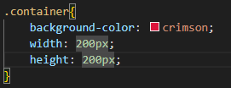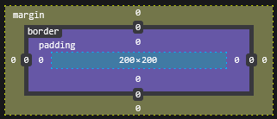

2. Padding
- The space between content and border.
- Expands the background around the content.
- Individual properties:
  - padding-top
  - padding-right
  - padding-bottom
  - padding-left
- Shorthand: padding (applies to all sides)
padding: 10px; /* all sides */
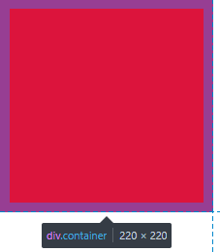

padding: 5px 10px 15px 20px; /* top | right | bottom | left */
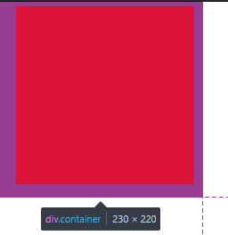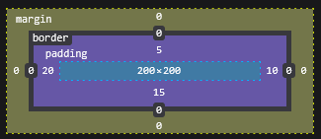

3. Border
- Wraps around the padding and content.
- Can be styled, colored, and given width.
- Individual properties:
  - border-top
  - border-right
  - border-bottom
  - border-left
- Each side can have:
  - border-width
  - border-style
  - border-color
- Shorthand: border
border: 5px solid black; /* width | style | color */
border-top: 5px dashed greenyellow;
border-left: 5px dotted blue;
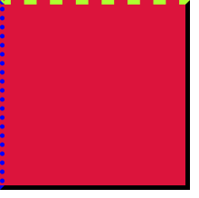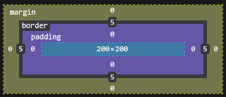

4. Margin
- The space outside the border.
- Creates distance between elements.
- Individual properties:
  - margin-top
  - margin-right
  - margin-bottom
  - margin-left
- Shorthand: margin
- Can take negative values.
margin: 20px; /* all sides */
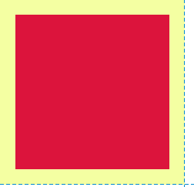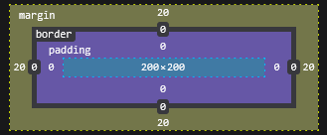
margin: 5px 10px 15px 20px; /*top | right | bottom | left */
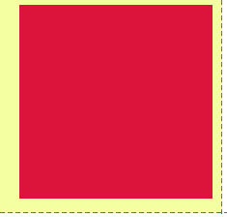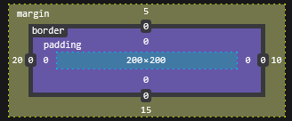
By default, width and height apply to content only (box-sizing: content-box).
If you use box-sizing: border-box, then padding and border are included in the width/height.
*{
box-sizing: border-box;
margin: 0px;
padding: 0px;
}

